Program No.
Secretariat use

IMPRES 2025 instructions for abstracts
Kenichi Tohoku¹ and Zundanuki Alice²
¹ Affiliations: The authors’ current affiliations. Address: The senior or corresponding author’s full mailing address (including country name), and e-mail address.
² Other author’s contact details, each placed in a separate line, without e-mail address.
1. Introduction
This document serves both as a guideline and a template for preparing your abstract for IMPRES 2025. To format your abstract correctly, please use the word styles defined in this document. On the review criteria, please see sub-section 3.1. written below.
2. Paper formatting
The manuscript should be written in English. The standard font for the abstract is Times New Roman for the text and Symbol for special characters. Body text should be the left-justified. The default font size for the body text has been set to 10 point. The paper size is A4 – 210 mm x 297 mm. The text should be in single column format. Margins are 30.0 mm top and left; 25.4 mm right and bottom.
The length of the abstract should be 2 pages inclusive of all figures, tables and references. The sections and sub-sections should be numbered. However, please do not use automatic paragraph numbering. The heading of a section should be in Times New Roman 11 point bold, the sub-sections in Times New Roman 10 point bold. Do not insert page numbers!
3. Content
3.1. Review criteria
Your abstract should be able to successfully convince the review panel of its scientific significance. Review criteria include originality, scientific/technical quality of your results, relevance to the conference topics and interest to conference participants. Depending on the quality of your abstract, you may be invited to present a poster or have an oral presentation at the conference.
3.2 Title
The abstract title should indicate the contents of the abstract with the first letter capitalized. If you need more than one line for the paper title please use a ‘soft’ line break (SHIFT+ Enter) instead of a line break.
3.3. Tables and figures
All figures and tables should be cited in the text, numbered in order of appearance. and a centered title followed by a centered title. Table captions should be centered and placed on top of the table. Text in each field of a table will look better if it has equal amounts of spacing above and below it.
Table 1: Table captions should be centered and placed on top of the table.
Table header | Header | Header
Tables | Text | Text
Figures | Text | Text

Accompanying comments can be included immediately after the table. Tables should be no larger than the printed area of the page, therefore, tables too large to fit on one page should be broken up into smaller tables.
Figures should be numbered consecutively with Arabic numerals and followed by an optional title. Please ensure that any color figures remain clear and understandable when reproduced in black and white. Regardless of the software used to create them, figures should be saved with the extension .jpg (minimum 300 dots per inch).
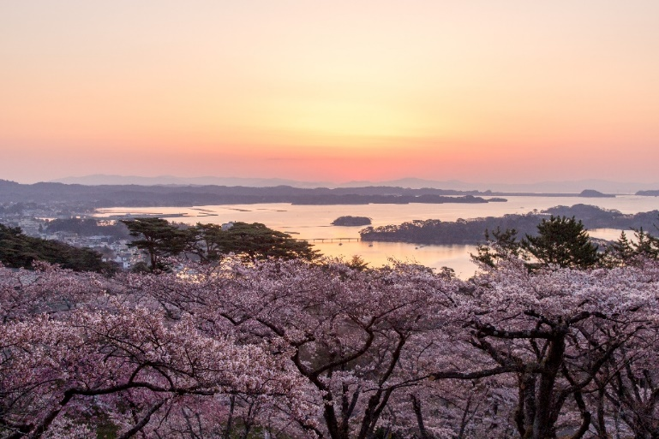

Fig. 1: Figure captions should be centered and placed below the figure.
3.3. Equations
If you would like to include an equation that cannot by typed on one line, please use an equations editor and insert it in the text close to the point where it is mentioned. Equations should be numbered, and the characters and symbols used in equations should be explained.
$D=\frac{a+bX_{1}+cX_{2}}{h^{3}}$ (1)
3.4. References
References should be numbered consecutively throughout the text and collected in a bibliographic list at the end of the paper. The reference heading should not be numbered. In the text, references are noted by Arabic numerals in square brackets, one space from words and punctuation. All works cited in the paper must be referenced.
4. Submission of abstract: Data formats and delivery
Each manuscript has to be handed in as .pdf file. The manuscript has to be uploaded to the IMPRES 2025 website ( https://www.senkyo.co.jp/impres2025/ ). All abstracts are to be submitted on or before February 15, 2025.
References
[1] N. Kato, (2022). Handbook of Thermophysical Properties, Sendai Press, Japan.
[2] N. Kato, K. Fujioka, N. Kitakawa, Journal of Recent Progress on Sendai Research, 5 (2018) 29-41.

